**ER DIAGRAM**

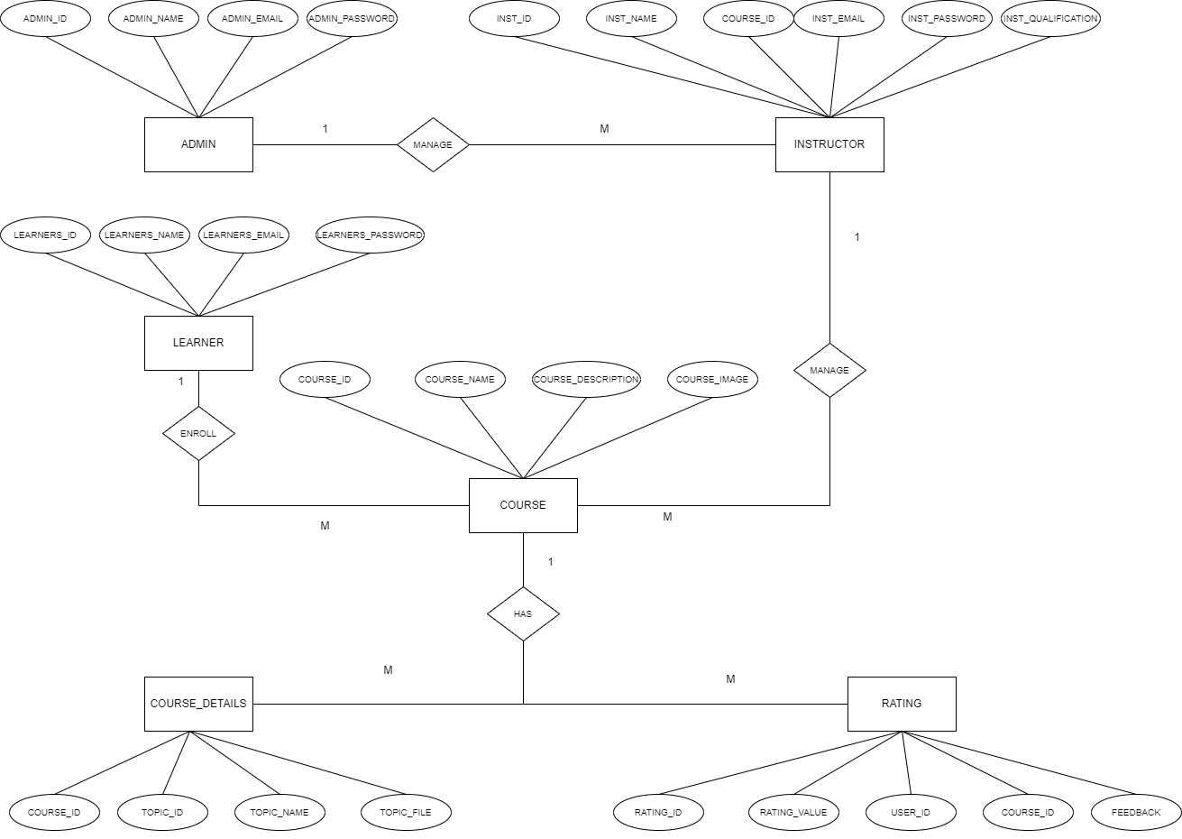

**PROJECT STRUCTURE**

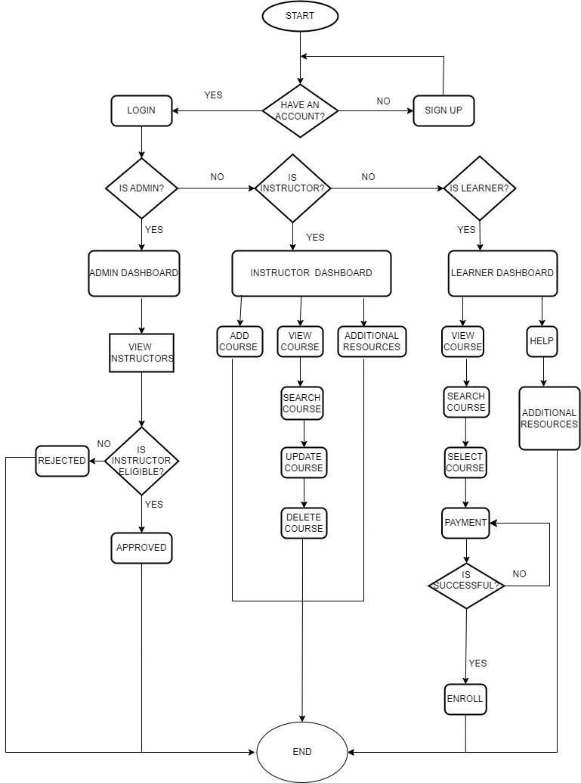

**Use Case Diagram**

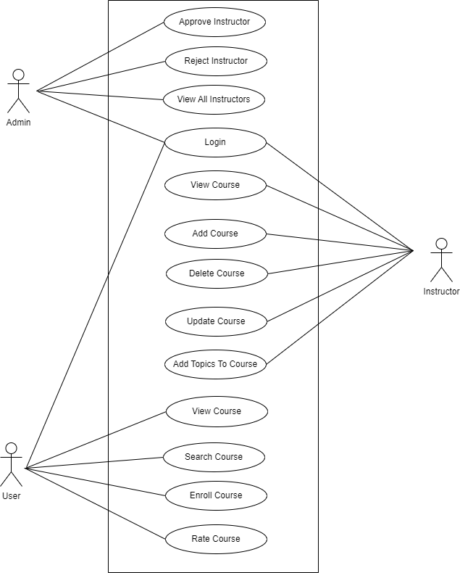

USE CASE DOCUMENT

**Use Case Document: E-Learning Management System - Learner**

|  |
| --- |
|  |
| **Use Case Name:** | Accessing and Participating in Courses |
| **Description:** | This use case describes the process of learners accessing and participating in courses on an e-learning management system. |
| **Actors:** | Learner: The user who wants to access and participate in courses on the e-learning management system. |
| **Preconditions:** | * The Learner has a valid account on the e-learning management system. * Courses are available on the e-learning management system. |
| **Postconditions:** | The Learner can access and participate in the selected courses. |
| **Flow of Events:** | 1. The Learner logs in to their account on the e-learning management system. 2. The e-learning management system presents the Learner's dashboard, displaying a list of available courses. 3. The Learner browses or searches for courses based on their interests or requirements. 4. The Learner selects a course from the list to access its details. 5. The e-learning management system displays the course details, including the title, description, instructor, and topics. 6. The Learner reviews the course details and decides to enroll in the course. 7. The e-learning management system prompts the Learner to confirm enrollment in the course. 8. The Learner confirms enrollment in the course. 9. The e-learning management system provides access to the course material, modules, lessons, or topics. 10. The Learner navigates to a specific module, lesson, or topic to start learning. 11. The e-learning management system presents the selected course material, which may include text, videos, presentations, quizzes, or interactive elements. 12. The Learner consumes the course material, taking notes or interacting with the content as needed. 13. The Learner can bookmark or mark their progress within the course material, allowing them to easily resume from where they left off. 14. The Learner can access additional resources or materials provided by the instructor, such as downloadable files, supplementary readings, or external links. 15. The Learner completes the course at their own pace, progressing through the modules or lessons. 16. Once the Learner completes all the required modules or lessons, the e-learning management system marks the course as completed. 17. The Learner can provide feedback or ratings for the course to help improve the learning experience and assist future learners. |
| **Alternative Flow:** | 3a. If the Learner has specific requirements or preferences   * The e-learning management system offers filtering or sorting options   6a. If the Learner is unsure about enrolling in a course:   * The e-learning management system provides course reviews, ratings, or previews to help the Learner make an informed decision. |

**Use Case Document: E-Learning Management System - Instructor**

|  |
| --- |
|  |
| **Use Case Name:** | Creating and Managing Courses |
| **Description:** | This use case describes the process of instructors creating and managing courses on an e-learning management system. |
| **Actors:** | Instructor: The user who creates and manages courses on the e-learning management system. |
| **Preconditions:** | * The Instructor has a valid account on the e-learning management system. * The Instructor has the necessary permissions to create and manage courses. |
| **Postconditions:** | * The Instructor can create, edit, publish, and manage courses on the e-learning management system. * Learners can access and enroll in the created courses. |
| **Flow of Events:** | 1. The Instructor logs in to their account on the e-learning management system. 2. The e-learning management system presents the Instructor's dashboard, displaying course management options. 3. The Instructor selects the "Create a Course" option. 4. The e-learning management system prompts the Instructor to provide course details, including title, description and category. 5. The Instructor enters the course details and proceeds to the next step. 6. The e-learning management system allows the Instructor to upload course content, such as video lectures. 7. The Instructor uploads the course content and organizes it into modules or sections as desired. 8. The e-learning management system provides tools for the Instructor to add supplementary resources, such as downloadable files, external links, or recommended readings. 9. The Instructor adds supplementary resources to enhance the course material. 10. The e-learning management system allows the Instructor to set pricing options for the course, including free or paid models. 11. The Instructor sets the pricing options and specifies the course fee if applicable. 12. The e-learning management system prompts the Instructor to publish the course. 13. The Instructor publishes the course, making it available for enrollment by learners. 14. The e-learning management system offers the Instructor the ability to preview and edit the course after publishing. |
| **Alternative Flow:** | 10a. If the Instructor wants to offer the course for free:   * The e-learning management system allows the Instructor to set the course as free, without any pricing options. |
| **Exceptions** | 1a. If the Instructor's login credentials are incorrect:   * The e-learning management system displays an error message indicating invalid credentials. * The Instructor is prompted to enter the correct username and password.   5a. If the Instructor does not provide mandatory course details:   * The e-learning management system displays an error message indicating missing information. * The Instructor is prompted to enter the required course details.   14a. If the Instructor wants to make further edits to the course after previewing it:   * The e-learning management system allows the Instructor to edit and update the course content after publishing.   16a. If the Instructor decides not to publish the course:   * The e-learning management system saves the course as a draft, allowing the Instructor to make further changes or publish it at a later time. |

**Use Case Document: E-Learning Management System - Admin**

|  |
| --- |
|  |
| **Use Case Name:** | Managing Instructors |
| **Description:** | The admin is responsible for managing instructors by approving or rejecting them, as well as viewing information about all instructors on the platform. |
| **Actors:** | Admin: The administrator of the E-learning platform. |
| **Approve Instructor Registration** |  |
| **Preconditions:** | The instructor has submitted a registration request. |
| **Postconditions:** | The instructor's account is approved and activated. |
| **Flow of Events:** | 1. The admin receives a registration request from an instructor. 2. The admin accesses the registration request queue. 3. The admin reviews the instructor's profile, qualifications, and credentials. 4. The admin approves the instructor's registration. 5. The system activates the instructor's account and sends a notification to the instructor. |
| **Reject Instructor Registration** |  |
| **Preconditions:** | The instructor has submitted a registration request. |
| **Postconditions:** | The instructor's account is rejected, and the instructor is notified. |
| **Flow of Events:** | 1. The admin receives a registration request from an instructor. 2. The admin accesses the registration request queue. 3. The admin reviews the instructor's profile, qualifications, and credentials. 4. The admin rejects the instructor's registration. 5. The system notifies the instructor about the rejection. |
| **View All Instructors** |  |
| **Preconditions:** | The admin is logged in to the admin dashboard. |
| **Postconditions:** | The admin has access to a list of all instructors. |
| **Flow of Events:** | 1. The admin navigates to the "Instructors" section of the admin dashboard. 2. The system fetches and displays a list of all instructors registered on the platform. 3. The admin can sort, filter, or search for specific instructors based on criteria such as name or subject. 4. The admin can select an instructor from the list to view detailed information about their profile and courses. 5. The admin can perform additional actions such an instructor if necessary. |
| **Alternative Flow:** | * If an instructor's registration request is rejected, they can resubmit their registration for admin review. * In the "View All Instructors" use case, if no instructors are registered, the system displays an appropriate message indicating the absence of data. |

